

**COMSATS University Islamabad,**

**Attock Campus, Pakistan**

**Immersive Game using Deep Learning**

***By***

**Anita Akram CIIT/FA19-BSE-073/ATK**

**Wajeeha Ibrahim CIIT/FA19-BSE-085/ATK**

***Supervisor***

**Dr. Muhammad Fahad Khan**

***Bachelor of Science in Software Engineering (2019-2023)***

**The candidate confirms that the work submitted is their own and appropriate credit has been given where reference has been made to the work of others.**

# DECLARATION

We hereby declare that this software, neither whole nor as a part has been copied out from any source. It is further declared that we have developed this software and accompanied report entirely on the basis of our personal efforts. If any part of this project is proved to be copied out from any source or found to be reproduction of some other. We will stand by the consequences. No Portion of the work presented has been submitted of any application for any other degree or qualification of this or any other university or institute of learning.

Wajeeha Ibrahim Anita Akram

FA19-BSE-085 FA19-BSE-073

Dated: Dated:

# CERTIFICATE OF APPROVAL

It is to certify that the final year project of BS (SE) “Immersive Game Using Deep Learning” was developed by Anita Akram (CIIT/FA19-BSE-073) and Wajeeha Ibrahim (CIIT/FA19-BSE -085) under the supervision of “Dr Muhammad Fahad Khan” and that in (their) opinion; it is fully adequate, in scope and quality for the degree of Bachelors of Science in Software Engineering.

---------------------------------------

Supervisor

---------------------------------------

External Examiner

---------------------------------------

Head of Department

(Department of Computer Science)

# Acknowledgement

All praise is to Almighty Allah who bestowed upon us a minute portion of His boundless knowledge by virtue of which we were able to accomplish this challenging task.

We are greatly indebted to our project supervisor “Dr Muhammad Fahad Khan”. Without their personal supervision, advice and valuable guidance, completion of this project would have been doubtful. We are deeply indebted to them for their encouragement and continual help during this work.

And we are also thankful to our parents and family who have been a constant source of encouragement for us and brought us the values of honesty & hard work.

Student 1 Student 2

--------------------------- --------------------

**Table of Contents**

DECLARATION 2

CERTIFICATE OF APPROVAL 3

Acknowledgement 4

**List of Tables** 7

**List of Figures** 8

Chapter 1 9

INTRODUCTION 9

1. Introduction 10

1.1. Relevance to Course Modules 11

1.1.1. Artificial Intelligence 11

1.1.2. Machine Learning 12

1.1.3. Report Writing Skills 12

1.1.4. Human Computer Interaction 12

1.2. Project Background 12

1.3. Literature Review 13

1.3.1. Related Work 13

1.3.1.1. Vision-based approach for human–computer interaction 13

1.3.1.2. Smart Sensors 14

1.3.1.3. Gesture Recognition using image processing 14

1.3.1.4. Gesture Recognition using smart sensors 15

1.3.2. HISTORY 17

1.4. Methodology and Software Lifecycle for this Project 17

1.4.1. Methodology 18

1.4.2. Rationale behind selected methodology 18

Chapter 2 19

PROBLEM DEFINITION 19

2. Problem Definition 20

2.1. Problem Statement 20

2.2. Deliverables and Development Requirements 20

Chapter 3 22

REQUIREMENT ANALYSIS 22

3. Requirement Analysis 23

3.1. Use Case Diagram 23

3.2. Detailed Use Case Diagram 24

3.2.1. Use Case #01(Play Game) 25

3.2.2. Use Case #02(Exit Game) 25

3.2.3. Use Case #03(Replay Game) 25

3.2.4. Use Case #04(Game menu) 26

3.2.5. Use Case #05(Hit obstacles) 26

3.2.6. Use Case #06(Collect fishes) 26

3.3. Functional Requirement 26

3.3.1. Player model 27

3.3.2. Camera position 27

3.4. Non-Functional Requirement 27

3.4.1. User friendly interface 27

3.4.2. Security 27

3.4.4. Maintainability 28

3.4.5. Efficiency 28

**Chapter 4** 29

**DESIGN AND ARCHITECTURE** 29

**4.1.** **System Architecture** 30

**4.2.** **Data Representation [Diagram + Description]** 31

**4.3.** **Process Flow / Representation** 33

4.3.1. **Activity Diagram** 33

**4.4.** Design Models 33

**4.4.1.** **Sequence Diagram** 33

**5.** **References** 35

**List of Tables**

**Table 1: Use Case 1** 26

**Table 2: Use Case 2** 26

**Table 3: Use Case 3** 26

**Table 4: Use Case 4** 27

**Table 5: Use Case 5** 27

**Table 6: Use Case 6** 27

**List of Figures**

Figure 1: Endless runners Subway Surfers, Temple Run 2 and Fotonica 12

Figure 2 Iterative Model 19

Figure 3: Top ranking games 21

Figure 4: Use case Diagram 25

*Figure 5 System Architecture* 31

*Figure 6-0-2: DFD Level 0* 32

*Figure 7 Game Flow Diagram* 33

Figure 8 Game Screen Flow 33

*Figure 9 Activity Diagram* 34

Figure 10 Sequence diagram 35

Figure 11 Sequence Diagram 35

# Chapter 1

# INTRODUCTION

## Introduction

An endless game is the concept in which player is able to play and get the game until it hit the obstacles and cached by the enemy. Its objectives are to get the as many points as possible. For example, “Temple Run”, “Subway Surf” etc. These types of endless games can be implemented in different ways. In our project we are going to implement a game to make it more interactive and enjoyable using our body movement. We will use our body to control the game character. We will use our body to move the character as left, right, jump, slide.

Gesture recognition involves extracting meaningful information regarding the motion of different parts of a human body like head, arms, face, or fingers for interacting with the environment. Gesture recognition is an area of utmost importance for the design of efficient and reliable human computer interaction (HCI) applications. Some of the common gesture recognition-based computer applications include remote robot control, elderly or disabled people activity monitoring, translation of sign language and driver drowsiness detection. Gesture recognition systems have been developed with the help of different kind of sensors, which include vision sensors as well as wearable sensors. Gesture recognition is a type of pattern recognition. Various methods could be utilized, such as conditional Gaussian models, support vector machines, Bayesian networks, dynamic time warping (DTW) and hidden Markov models (HMMs).

Games remain the most popular category on both the Android and iOS app stores with approximately 20% of each app store devoted to games. Games also dominate in terms of user base and revenue generated. With the ever increasing number of mobile and web based games, player engagement becomes increasingly important in game design. Specifically, it is not enough to just motivate users to install and begin playing a game; if the engagement is not maintained at a high level, users can quickly switch to other games or applications as they have many options available in the app stores. User engagement has been defined as the emotional, cognitive, and behavioral connection that exists, at any point in time and possibly over time, between a user and a technological resource. Most popular endless runner games are Subway surf, Temple Run and Fotonica.

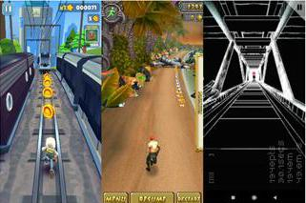

Figure 1: Endless runners Subway Surfers, Temple Run 2 and Fotonica

Thus to increase the user engagement in game, we have incorporated the concepts of Deep Learning in our Endless Run Game. Our Endless Run game shall recognize and classify different gestures of player and operate accordingly, thus giving the user a virtual environment to play.

### Relevance to Course Modules

#### Artificial Intelligence

In that course all machine learning techniques and algorithms are part of it. The topic that closely relates with my project is Deep Learning. An artificial neuron is developed by machine learning technique to replicate the biological neuron. Neural networks comprise of technologies like machine learning concepts and deep learning and form a part of Artificial Intelligence.

#### Machine Learning

In this course we have studied about different algorithms which are used to train models to perfume task automatically after getting the training data.

#### Report Writing Skills

This course is about learning how to write reports and other formal documentation, and, in our project, we need to write our documentation, so this course is helping a lot in this task.

#### Human Computer Interaction

A system which is interactive is easy and comfortable for the user to use the system and understand it easily and this course is all about designing interacting system following standard rules.

### Project Background

Recognition of human gestures have become a research area of great interest in many potential application domains including:

* Human-computer interfaces
* Interactive video games
* Automated surveillance of parking lots

Real-time gesture recognition in complex situations has numerous challenges such as environmental conditions. Rather than being a passive observer, users prefer to engage in the environments as an active participant using various gestures. Smart sensors help to reduce storage requirement and computational time required by computer vision-based systems. In past many projects have been developed using gesture recognition but they are mostly image-based recognition. There are certain drawbacks of using image processing in this filed. Like image-based projects fails badly under bad lightning conditions. Certain researches have been shared regarding this filed in which engineers have used different methods for recognition of gestures. But a very little study has been done in the field of identification of object with which the human is interacting or which is being used to perform the activity.

### Literature Review

With a specific end goal to influence the task, to yield appropriate output, it is important to experience the past looks into and procedures. This heading contains the complete description of the past work and reports that have been completed in such manner. Different approaches have been used in past few decades for gesture recognation. We illustrate how these approaches differ from each other, bring to light the merits of each and limitations. A task is accomplished with specified goal to achieve a desired output, it is necessary to go through past researches and techniques for evaluating accuracies. Different approaches have been used in past few decades to detect posture or gestures. These techniques differ from each other, bring to light the merits of each and limitations with respect to our problem. We used Deep Learning approach to carry out our problem. It involves core concepts of Artificial Intelligence which is a subset of deep learning. Artificial Intelligence is the domain we worked in. In past, machine learning based approaches used for yielding maximum accuracies and appropriate outcomes.

### Related Work

A wide range of literature is available on gesture recognition systems. The techniques used in them are categorize into two parts:

#### Vision-based approach for human–computer interaction

A vision-based approach is used to build a dynamic hand gesture recognition system. Various challenges such as complicated background, change in illumination and occlusion make the detection and tracking of hand difficult in any vision-based approaches. To overcome such challenges, a hand detection technique is developed by combining three-frame differencing and skin filtering. The three-frame differencing is performed for both colored and grayscale frames. The hand is then tracked using different digital image algorithms.

#### Smart Sensors

Various technologies has been used for the design and implementation of such kind of devices, but contact based and vision based technologies are two main types of technologies used for robust, accurate and reliable hand gesture recognition systems. Contact based devices like accelerometers, multi-touch screen, data glove etc. based on physical interaction of user who will be required to learn their usages. The research done on smart sensors is not much.

Several projects have been done in the domain of gesture recognition. These systems recognize gestures either using images/webcam or smart sensors. There are certain drawbacks in image recognition domain like project fails under bad lightning conditions.

#### Gesture Recognition using image processing

Static hand gesture recognition system (capable of detecting 24 gestures) using image processing was developed which classifies gestures as:

* A
* B
* Upto Z

For this purpose, Convolutional Neural Network was built and different techniques were involved like:

* Image-preprocessing
* Feature extraction
* Classification

In pre-processing phase certain techniques are applied to differentiate the foreground and background like in this step the pixels values are inverted for the better enhancement of the image. The inversion is performed because in the next few steps we are going to detect the contours and convexity defect and for that it is better to make the background black and foreground white.

The authors identifed the hand region from input pictures and after that track and analyze the moving way to recognize America sign dialect. Shimada et al. propose a TV control interface utilizing hand signal acknowledgment. Keskin et al isolate the hand into 21 diverse districts and prepare a SVM classifier to demonstrate the joint conveyance of these districts for different hand signals so as to classify the signals.

Zeng et al. move forward the therapeutic benefit through the hand signal acknowledgment. The HCI acknowledgment framework of the cleverly wheelchair incorporates five hand signals and three compound states. Their framework performs dependably within the environment of indoor and open air and within the condition of lighting alter.

#### Gesture Recognition using smart sensors

Wrist rotate system is a personalized system to eliminate the issue of confusion between relevant and non-relevant gestures. The system uses five arm gestures i.e. pull, push, curl, rotate and double rotate. The system is based upon Dynamic Time Warping and double flip to partition a stream of accelerometer readings to identify possible gestures.

Continuous authentication has been done via mobile phone (handheld device) based upon pattern recognition while using smartphone. Six different daily activities are identified in the system using Support Vector Machine (SVM), Decision tree ( DT), and K Nearest Neighbor (KNN).

Gestures produced by arm, hand and fingers are used to identify the alphabet and proved that smartwatch is sufficient to recognize the gesture type (hands, arms, fingers) and the gestures produced by them using accelerometer and gyroscope. In this research alphabets are drawn using index finger which are recognized using Naïve Bayes (NB), Logistic Regression (LR) and Decision Tree (DT). Glove based recognition system is proposed to identify the gestures (Vietnamese Sign Language). Ten flex sensors and one accelerometer is designed to identify alphabets and digits by dividing them into three different categories.

In past gesture recognition system was developed using inertial sensors. Inertial sensors are sensors based on inertia and significant measuring standards. These extend from Small scale Electro-Mechanical Frameworks (MEMS) inertial sensors, measuring only few mm, up to ring laser gyroscopes that are high-precision gadgets with an estimate of up to 50cm size. The accessibility of inertial sensors implanted in portable devices has empowered a modern sort of interaction based on the developments or “gestures” made by the clients when holding the device. A gesture acknowledgment framework for portable gadgets based on accelerometer and gyroscope measurements was designed. The framework is competent of recognizing a set of predefined motions in a user-independent way, without a training stage. Moreover, it was outlined to be executed in real-time in resource-Constrained devices, and so includes a low computational complexity.

The performance of the framework is assessed offline employing a dataset of signals, additionally online, through a few client tests with the system running in a smart phone. The system was designed with six orientations with respect to ground i.e., horizontal up, vertical up, left, horizontal down, vertical down, right. In 2016, a similar system was developed in which instead of using the sensors of smart phone, a foot mounted inertial based sensor was used.

In this system inertial parameters were measured using Inertial Navigation System. Practical experiment results illustrate that the proposed framework is able of recognizing five-foot motions, jump, step left, step right, step forward, and step backward, and has accomplished an over 97% accuracy performance for different clients. This system used different algorithms like KNN, SVM and decision tree.

#### HISTORY

Sometime players cannot play games in a specific way. One example is the globally acclaimed Monster Hunter World was failed badly. This game was criticized for various nagging problems. So, our 3D game application will be Innovative than others. In this game, user can easily understand and play any game using his body and can understand in the initial stage within one or two attempts.

### Methodology and Software Lifecycle for this Project

Project methodology is an important phase of any project because it is a key element and set the overall tone. For this we must first understand the steps that are involved in project methodology. We use iterative approach to develop this application.

#### Methodology

Software development methodology involves splitting the work into different stages with the goal of better management, planning and understanding Software.

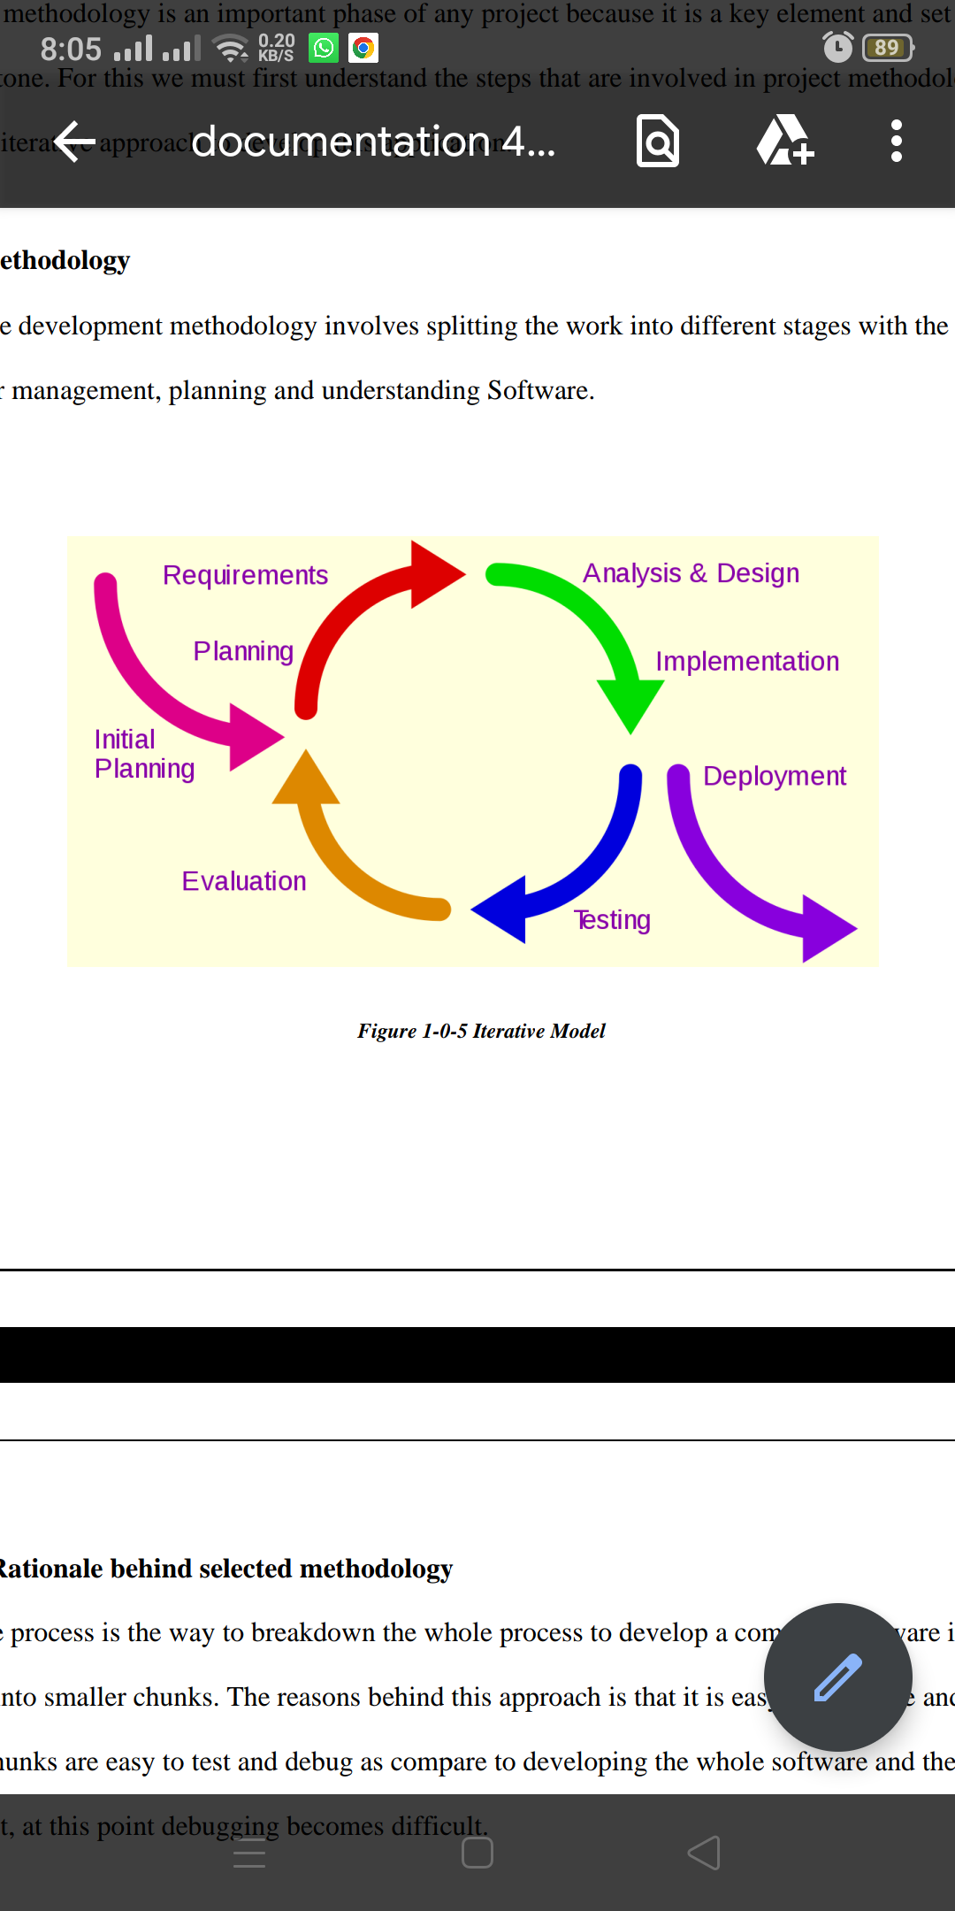

Figure Iterative Model

#### Rationale behind selected methodology

Iterative process is the way to breakdown the whole process to develop a complete software in one go into smaller chunks. The reasons behind this approach is that it is easy measurable and small chunks are easy to test and debug as compare to developing the whole software and then testing it, at this point debugging becomes difficult.

# Chapter 2

# PROBLEM DEFINITION

1. Problem Definition

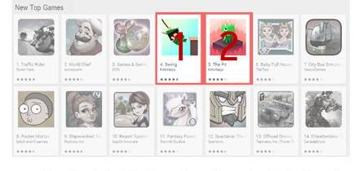The market of mobile applications has been growing ever since Google and Apple published their app stores. Thus the demand for mobile applications and games has increased. It leads many developers to this domain. So the market is highly competitive and almost one third of the applications are games. Different type of endless games keep showing on the top of the app stores rankings. So we decided to make it a different by making it immersive.

Figure : Top ranking games

## Problem Statement

With the development of ubiquitous computing, current user interaction approaches with keyboard, mouse and pen are not sufficient. Due to the limitation of these devices the useable command set is also limited. Direct use of body motion can be used as an input device for providing natural interaction. There are also many other way to develop natural interactions but smart-senor based activity is emerging in domain of machine and deep learning.

## Deliverables and Development Requirements

Using Deep Learning approach, we will develop a project that will control games (real world application) using smart sensors present in your mobile. There will be a system which will recognize five motions Left, Right, Run, Jump and Slide. So, we will have two things at the end of a game developed using python and smart sensors to control that game.

**Development requirements include following software requirements:**

* IDE: Jupyter Notebook
* Anaconda
* Programming Language for Game: C#
* Programming Language for Deep learning module: Python
* Interface: Unity 3D and Blender
* Integration: JavaScript

# Chapter 3

# REQUIREMENT ANALYSIS

## Requirement Analysis

Software Requirement Analysis (SRS) is provides the basic understanding of functional as well as non -functional requirements. We can consider it as a starting point of project because it serves as written contract between client and organization about the features and functionalities of the project. With the help of SRS both client and organization make clear to each other about the deliverable project.

### Use Case Diagram

A realistic picture of the connections among the components of a framework is known as use case diagram. A use case diagram is a technique utilized as a part of framework investigation to perceive and arrange framework necessities. We design UML (Unified Modelling Language) figures to model a framework in the simple and efficient way. UML describes several types of the diagram to cover all aspects of the framework because it is not enough to define all aspects of the system using single UML diagram.

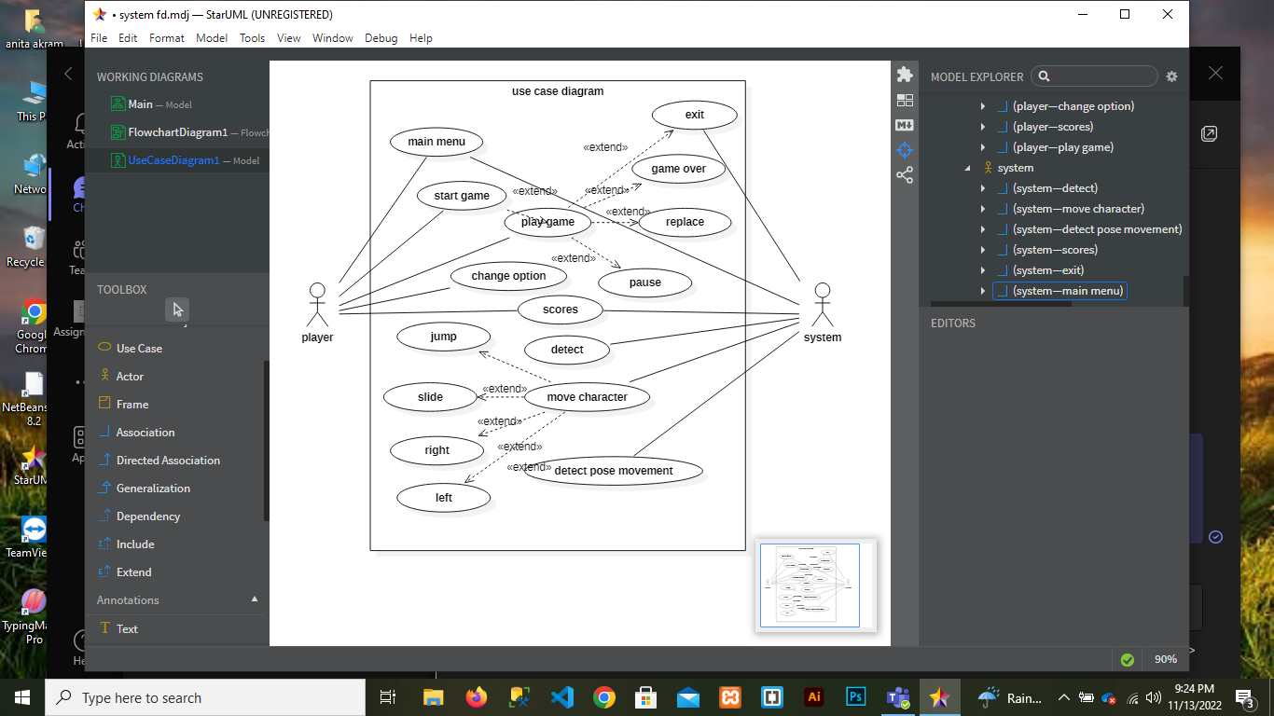

Figure : Use case Diagram

### Detailed Use Case Diagram

Use case figure is one of the UML diagrams which models dynamic behavior. It is dynamic in nature, consisting of some inside or outside components for making the connection. It is a set of use cases, actors (primary and secondary actor) and relationships. A use case diagram is used to represent a particular functionality of a system. Many use cases diagrams are used to model the entire system. It is a generic way to define that use case diagram captures all dynamic aspects of the entire system.

#### Use Case #01(Play Game)

**Table 1: Use Case 1**

|  |  |
| --- | --- |
| **Use Case ID** | Use Case 1 |
| **Use-case name** | Play |
| **Actor** | Player |
| **Description** | This will start when player open the game and click the start button. |
| **Pre-condition** | Open the game |
| **Post-condition** | Play button is working play the game. |

#### Use Case #02(Exit Game)

**Table 2: Use Case 2**

|  |  |
| --- | --- |
| **Use Case ID** | Use Case 2 |
| **Use-case name** | Exit |
| **Actor** | User |
| **Description** | Click on exit button to end the game. |
| **Pre-condition** | Game is open |
| **Post-condition** | After pressing exit button, game will close from mobile screen. |

#### Use Case #03(Replay Game)

**Table 3: Use Case 3**

|  |  |
| --- | --- |
| **Use Case ID** | Use Case 3 |
| **Use-case name** | Replay |
| **Actor** | User |
| **Description** | When actor wants to play the game again this use case will start. |
| **Pre-condition** | When user hit the obstacles or want to restart the game |
| **Post-condition** | If user wants to play the game again then click on replay button otherwise press exit button. |

#### Use Case #04(Game menu)

**Table 4: Use Case 4**

|  |  |
| --- | --- |
| **Use Case ID** | **Use Case 4** |
| **Use-case name** | Main menu |
| **Actor** | User |
| **Description** | If user wants to see first screen which is play or exit or game setting, this use case will start. |
| **Pre-condition** | When user hit the obstacles this button will show |
| **Post-condition** | User can select any button which he wants. |

#### Use Case #05(Hit obstacles)

**Table 5: Use Case 5**

|  |  |
| --- | --- |
| **Use Case ID** | **Use Case 5** |
| **Use-case name** | Hit obstacles/ Hurdles |
| **Actor** | User |
| **Description** | When user play the game and hit by any obstacles or hurdles he will be out of the game. |
| **Pre-condition** | Playing the game. |
| **Post-condition** | Back to the main menu. |

#### Use Case #06(Collect fishes)

**Table 6: Use Case 6**

|  |  |
| --- | --- |
| **Use Case ID** | **Use Case 6** |
| **Use-case name** | Collect fishes |
| **Actor** | Users |
| **Description** | User is playing the game and running to collect the fishes. |
| **Pre-condition** | Player is running |
| **Post-condition** | Total fishes the collected. |

### Functional Requirement

This section provides the analysis of the requirements that system will proposed. Functional requirement describes the predictable behavior of the framework. These are main framework requirement and without applying any of these requirements the framework should be fragmented.

**FR -1** User will see the 3D route.

**FR-2** User will see the 3D places around the road.

**FR-3** There will have a player character.

**FR-4** Player will have replay the game after getting hit by any obstacles.

**FR-5** The actor will run according to the body movement of the user.

#### Player model

It will have one playable character for the player. It will be the main character of the game. All game depends on it because, it was controlled by the player to complete the mission.

#### Camera position

It will use a camera with the right position. With this player will control the character movement and running.

### Non-Functional Requirement

#### User friendly interface

The interface will be easy to use and user friendly. It will have attractive User Interface. The button’s names and menus will be self-explanatory. Its language will be simple and correct so that any country’s player can understand it.

#### Security

The system will provide facility to ensure that all players play the game and avoid hackers. It will be recoverable in case of any disaster.

* + 1. **Portability**

The game will be able to run on all type of android smart phones. To run the game it will require minimum 2gb of ram and minimum kitkat version above 4.0.0.

#### Maintainability

With the time and needs our system will be maintained properly and any feedback from the user is our priority while performing maintenance.

#### Efficiency

This system will be efficient as it does not require any kind of effort to use it and also does not take much time.

* + 1. **Flexibility**

The system will be flexible the user will easily see the graphics.

**Chapter 4**

**DESIGN AND ARCHITECTURE**

1. **Design and Architecture**

After gathering all requirements, the next step is to start planning that how we are going to develop our project, how much resources, costs, time, benefits and other items are required. After planning we move to the designing and architecture phase that which techniques and methods we can use and how we are going to develop our project. It is the most important and challenging phase of project development.

* 1. **System Architecture**

We are developing a game in which there will be character which will be controlled by the movement of the player. System will recognize these movements and character will pay according to this movement. It is an endless runner game, when it will hit the obstacles the game will over.

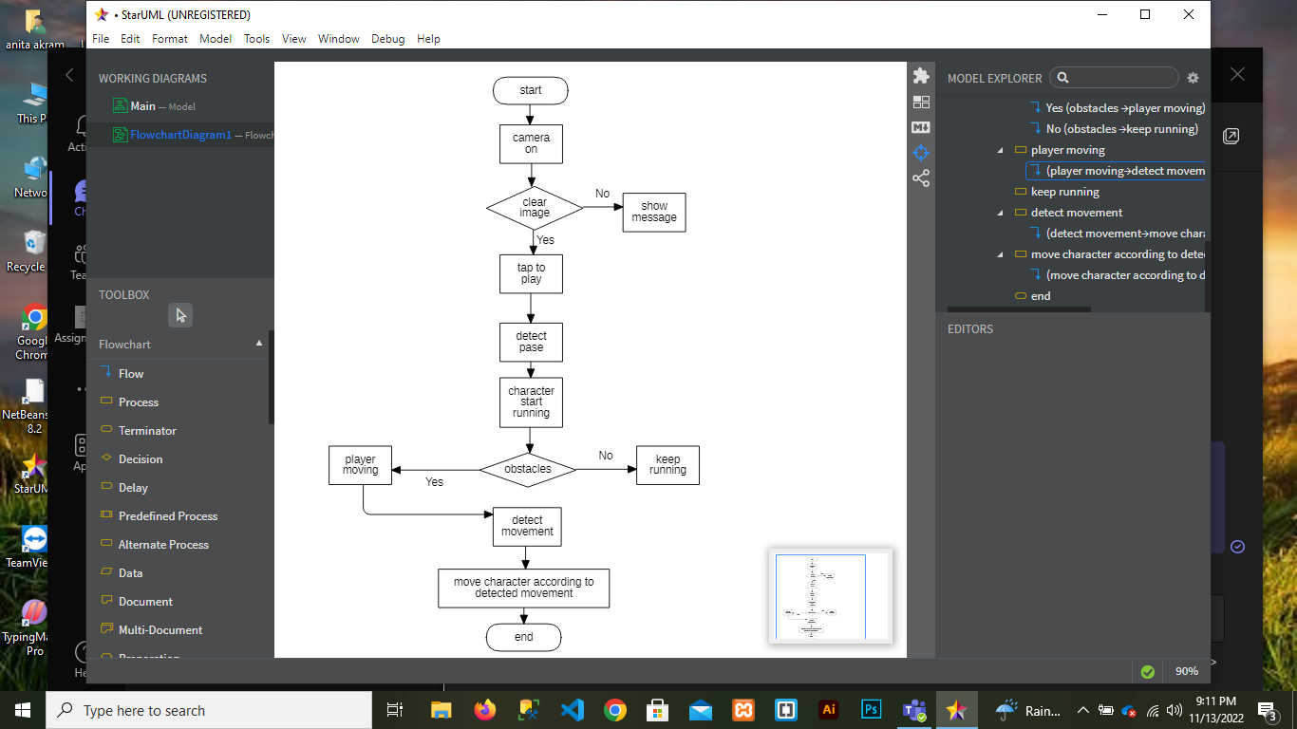

*Figure 5 System Architecture*

* 1. **Data Representation [Diagram + Description]**

A data flow diagram is graphical interpretation of information move from a data framework is called DFD (data flow diagram). A DFD is used for basic step to create an overview of the system without going into great aspect, which can later be elaborated.

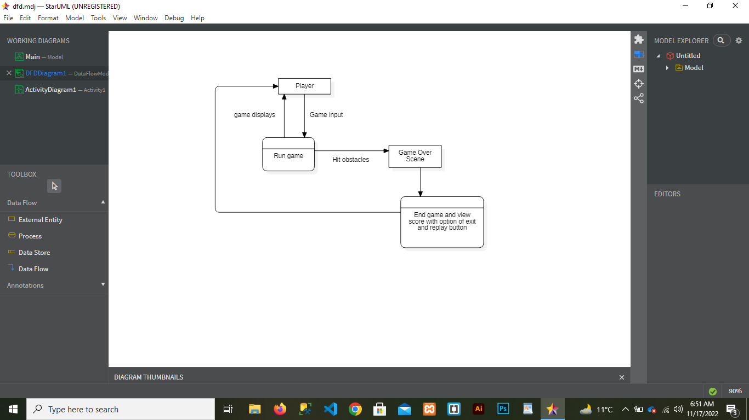

*Figure 6-0-2: DFD Level 0*

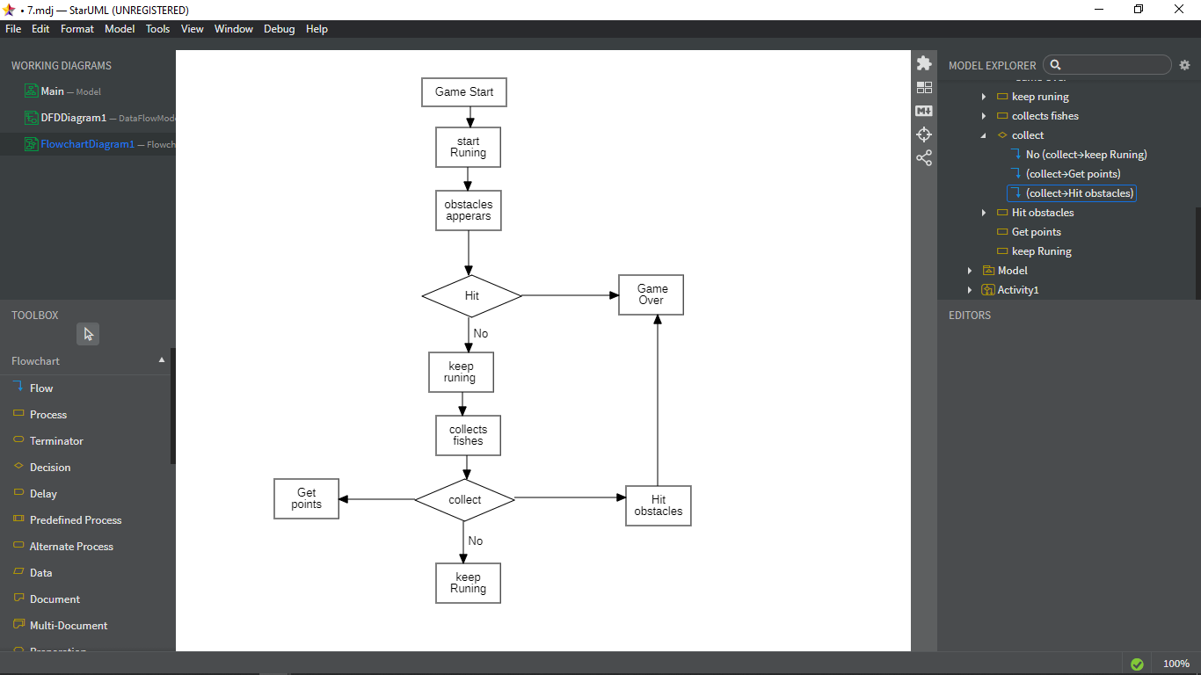

*Figure 7 Game Flow Diagram*

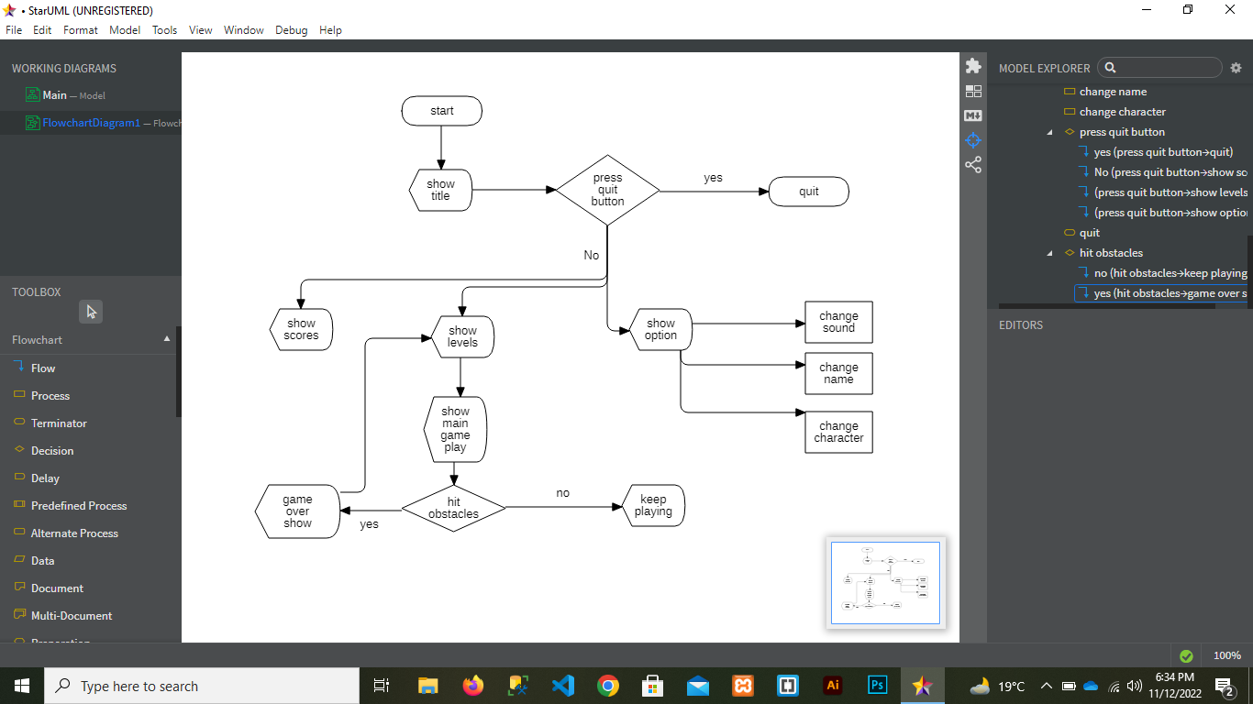

Figure Game Screen Flow

* 1. **Process Flow / Representation** 
     1. **Activity Diagram**

An activity diagram is depicting the dynamic component of the framework. An activity diagram is essentially a flowchart to speak from one action to another movement. The movement may be relating to an operation of the framework. This diagram is used to explain the dynamic features of the system. It is more like a flow chart because it shows the flow of data from one activity to other.

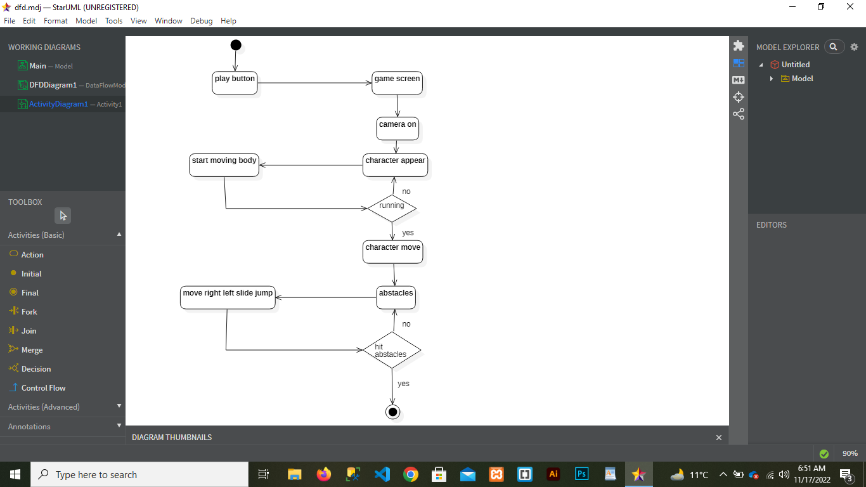

*Figure 9 Activity Diagram*

* 1. Design Models
     1. **Sequence Diagram**

A cooperation graph that shows how objects work with each other and in what request is called sequence diagram. It is built up of message arrangement outline.

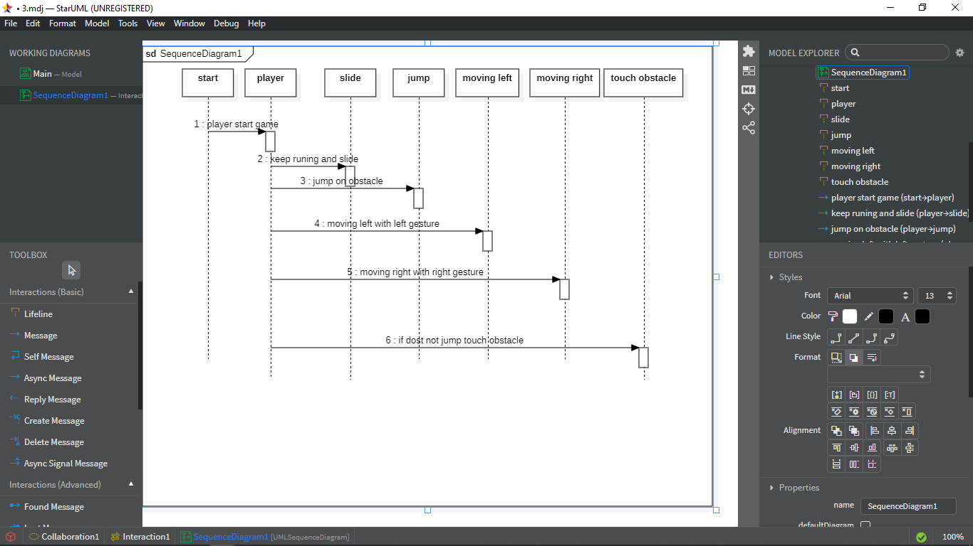

Figure Sequence diagram

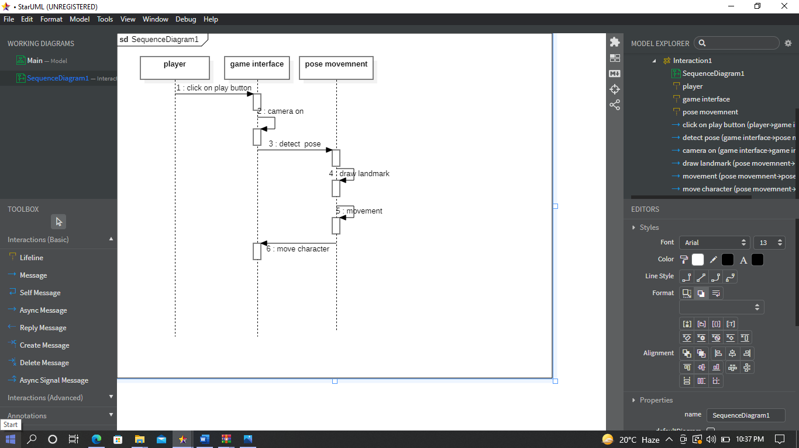

Figure Sequence Diagram

1. **References**
2. M. A. A. ,. I. C. P. Carlos D. B. Borges, "Static Hand Gesture Recognition Based on Convolutional Neural Networks," vol. 2019, 5 September 2019.
3. J.-T. K. L. hi-hua Chen, "Machine Learning in Intelligent Video and Automated Monitoring," vol. 2014, May 2014.
4. F. P. S. a. M. L. Kerber, "WristRotate: a personalized motion gesture delimiter for Wrist-Worn Devices," 2015.
5. M. A. A. Muhammad Ehatisham-ul-Haq, "Continuous authentication of smartphone users based on activity pattern recognition using passive mobile sensing," March 2018.
6. C. P. P. a. P. M. Xu, "Finger-writing with smartwatch: A case for finger and hand gesture recognition using smartwatch. in Proceedings of the 16th International," 2015.
7. L. e. a. Phi, "A glove-based gesture recognition system for Vietnamese sign language.," 2015.
8. H. Z. Qifan Zhou, "Design and Implementation of Foot-Mounted Inertial," 18 October 2018.
9. P. T. E. M. A. M. B. a. J. R. C. Xian Wang, "Gesture Recognition Using Mobile Phone’s Inertial Sensors".